**N.NITHIN**

**2420030488**

**Sec-2**

**Task 2**

**Execute the following network commands like ipconfig, tracert, telnet, ping, nslookup, netstat**

**Procedure:**

**Step 1:** Launch CISCO packet tracer; double click the cisco packet tracer icon on your desktop or find it the search bar or applications list and open the program. **Step 2:** Create a simple network topology

1. Add devices

Drag and drop a router and switch from the device list on to the workspace Drag and drop 2 PC’s on to the workspace

1. Connect devices:

Use the connection tool to connect the devices

* + Connect one PC to the switch using the Copper Straight-Through cable
  + Connect the switch to the router using another Copper Straight-Through cable
  + Connect the second PC to the switch using Copper straight-Through cable

1. Configure devices:

➔ Configure the router:

* + Click on the router
  + Go to config tab
  + Assign IP address to the router interfaces

**Ex:**

1. [PC0]

Interface G0/0/0

IPv4 add = 192.168.1.1

Subnet mask = 255.255.255.0

1. [PC1]

Interface G0/0/1

IPv4 add = 192.168.2.1

Subnet mask = 255.255.255.0

4) Configure the PC’s:

* Click on each PC
* Go to the desktop option
* IP configuration
* Assigning IP addresses to each PC

Ex:

* 1. [PC0]

IP: 192.168.1.2

Subnet mask = 255.255.255.0,

Default gateway = 192.168.1.1

* 1. [PC0]

IP: 192.168.2.2

Subnet mask = 255.255.255.0,

Default gateway = 192.168.2.1

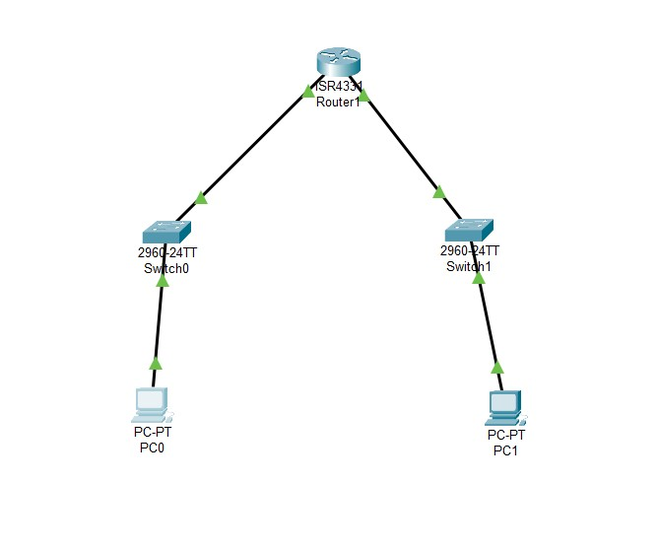

**Step 3:** Execute networking commands

1. **Command ipconfig:**

This command displays all current tcp ip network configurations values and all DHCP and DNS settings.

Open the command prompt of PC0:

* + Click on PC0
  + Go to the desktop tab
  + Open the command prompt
  + Type command **ipconfig** **Output:**

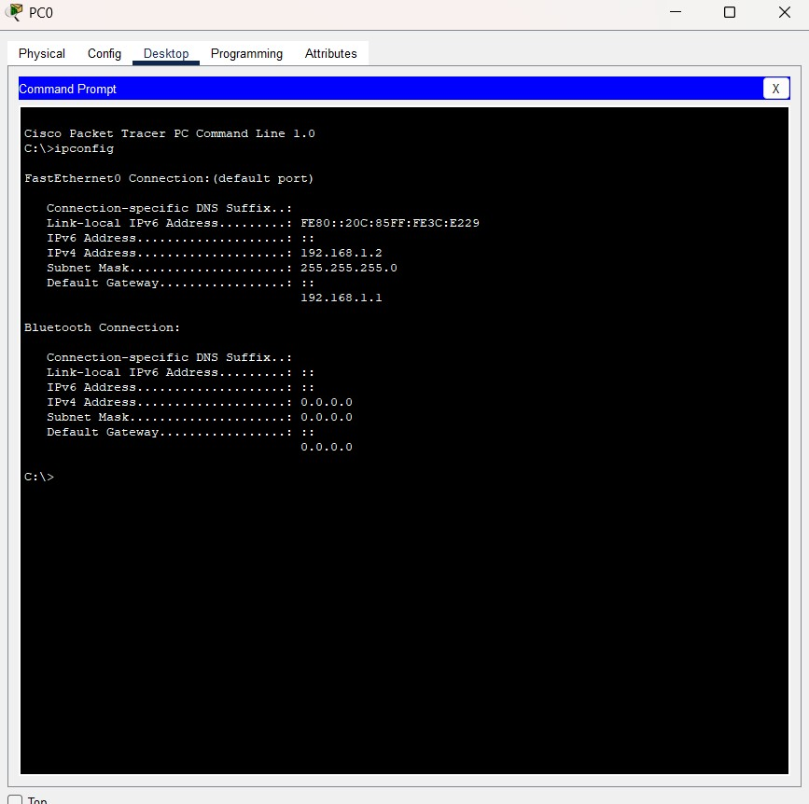

* + Follow the same steps for PC1: The output will be

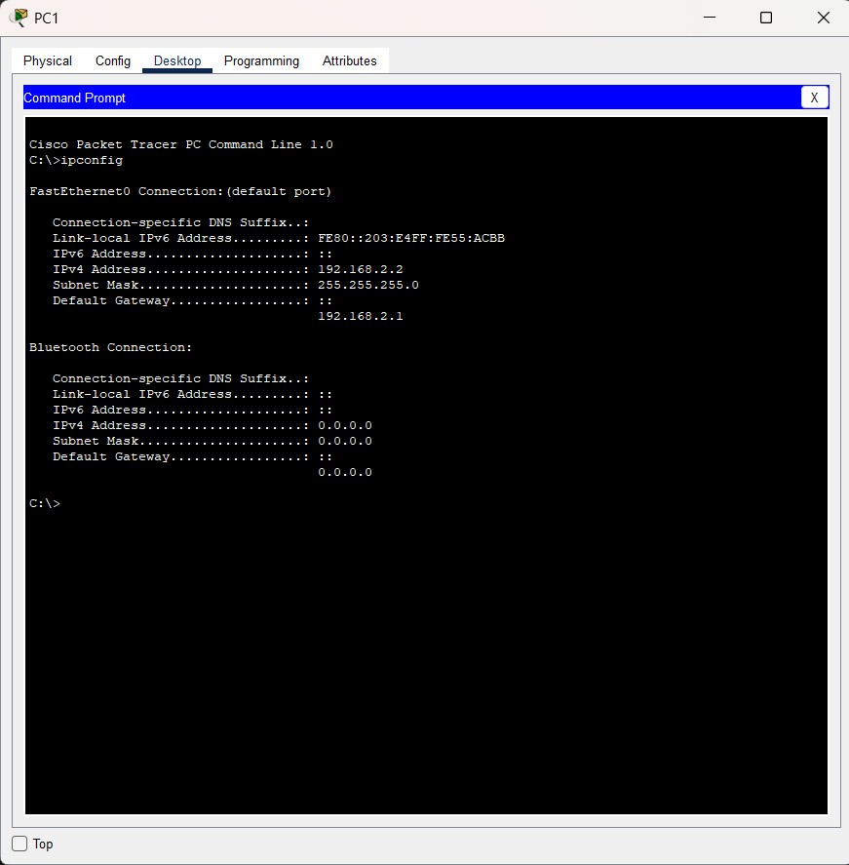

1. **Command tracert:**

This command traces the path taken to a destination by sending ICMP echo request messages

**Step1:**

* + Click on PC0
  + Go to desktop tab
  + Open the command prompt

Commnad: tracert 192.168.2.2

**Output:**

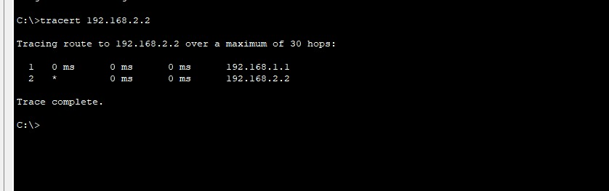

1. **Command telnet:**

Telnet is an unencrypted protocol and is not secure. For real-world applications, consider using SSH to secure remote connections.

**Step1:**

* + Click on the router
  + Go to the config tab
  + Select the interface connected to the switch (e.g. G0/0)
  + Assign IP address 192.168.1.1, Subnet mask: 255.255.255.0
  + Open the CLI and type exit until you get this

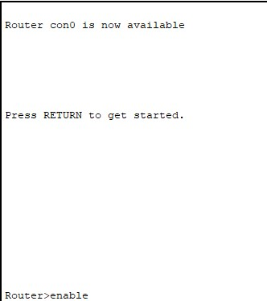

* + Once you get this type all these commands:

Router>enable

Router#configure terminal

Enter configuration commands, one per line. End with CNTL/Z.

Router (config) #line vty 0 4

Router (config-line)#password cisco

Router (config-line)#login

Router (config-line)#exit

Router (config-line)#exit

Router (config)#end

Router#

\SYS-5-CONFIG_I: Configured from console by console Router#write memory Building configuration...

[OK]

Router#

**Reference image to write the commands**

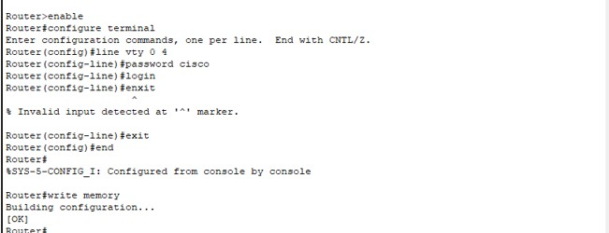

**Step2:**

* Now open the Command prompt of PC0
* Click on the PC0
* Click on the desktop
* Then click on the command prompt
* Enter the command: telnet 192.168.1.1
* You can see the password: type cisco Your command execution is completed

**Output:**

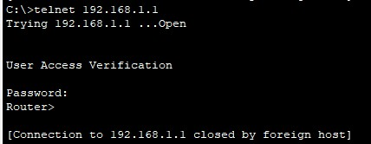

**Router configuration and brief ip interface:**

➔ **Note:** This should be done in the CLP (Command line interface) of the router

**Command:** show ip interface brief **Output:**

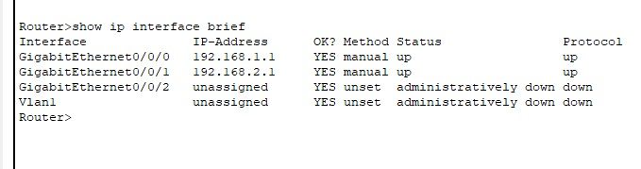

1. **Command ping:**

The ping command is used to **test network connectivity** between two devices. It checks if one device (like a PC) can reach another device (like a router, server, or website) and measures how long it takes.

* + Click on the PC0
  + Click on the desktop
  + Click command prompt
  + Type the following command
  + Command: ping 192.168.2.2

**Output:**

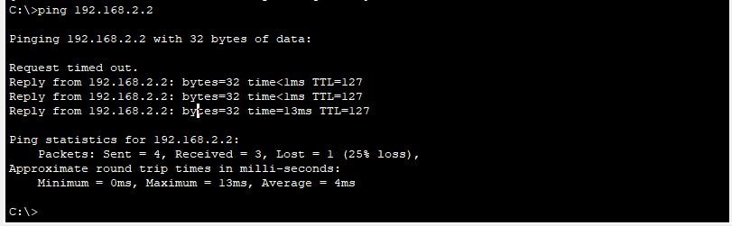

1. **Command nslookup:**

This command queries the DNS to obtain domain name or IP address maping.

To use the nslookup command to resolve a domain name to an IP addressin Cisco Packet Tracer, you’ll need to ensure that the DNS server is properly configured in your netwok topology.

**Step 1:** Add one server (to act as a DNS server).

**Step2:** Connect both PCs and the server to the switch using copper straightthrough cables. Configure the DNS Server

1. Assign IP Address:

* Click on the server.
* Go to the Config tab and select the FastEthernet0 interface.
* Assign

IP address: 192.168.1.3, Subnet Mask: 255.255.255.0,

Default Gateway: 192.168.1.1.

Configure DNS Service:

* Go to the Services tab on the server.• Select DNS and turn the service On.
* Add an entry for www.google.com with an IP address (e.g., 8.8.8.8).
* Use the nslookup Command

**Step3:** Open Command Prompt on PCO:

* Go to the Desktop tab on PCO.
* Open the Command Prompt. 2.
* Execute the nslookup
* Command: nslookup www.google.com

**Output:**

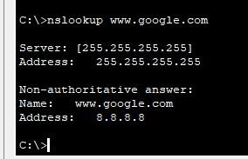

**6.Command netstat:**

* This command displays network connections for the Transmission Control Protocol (TCP), routing tables, and a number of network interface and network protocol statistics.
* The netstat command is used to display network connections, routing tables, interface statistics, masquerade connections, and multicast memberships.

**DNS Server Configuration:** Ensure that the DNS server is correctly configured and running.

**DNS Entries:** The DNS entry for www.google.com should be added to the DNS server with an IP address.

**Network Configuration:**

Ensure that all devices are correctly connected and configured with appropriate IP addresses, subnet masks, and default gateways.

